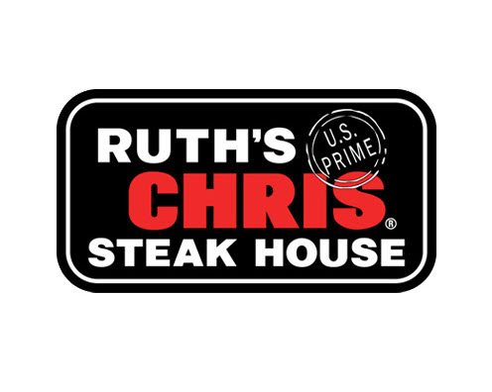
Choices from this menu are $45.24 per person for the 3-course meal.

starters (select one)

CAESAR SALAD
STEAK HOUSE SALAD

entrees (select one)
6 OZ FILET* the same incredible cut as the classic, in a 6 ounce filet

STUFFED CHICKEN BREAST oven roasted double chicken breast, garlic herb cheese, lemon butter

LEMON BUTTER KING SALMON* lightly seasoned over garlic sauteed spinach

entrée complements
LOBSTER TAIL 20
BLEU CHEESE CRUST 6
OSCAR STYLE 18
GRILLED SHRIMP 17

sides (select one)
CREAMED SPINACH
GARLIC MASHED POTATOES

dessert
BREAD PUDDING vanilla, raisins and a Jack Daniels whiskey sauce

perfect pairings
offered by the bottle

las huertas, CHARDONNAY 38
las huertas, CABERNET SAUVIGNON 38

No Substitutions Please | Tax & Gratuity Not Included
Not available for parties larger than 8 (based on availability)
2,000 calories a day is ued for general nutrition advice, but calorie needs vary. Additional nutritional information available upon request. *Items are served, raw, or undercooked, or may contain raw or undercooked ingredients. Consuming raw or undercooked meats, poultry, seafood, shellfish or eggs may increase your risk of food-borne illness.

